Logistics and Rollout Plan

Woodgrove Bank Reach Portal

## Document Status

|  |  |
| --- | --- |
| Title | Logistics and Rollout Plan |
| Author(s) | John Smith |
| Team | Reach Portal project |
| Version | v0.2 |
| Status | Draft |

## Change Record

|  |  |  |  |
| --- | --- | --- | --- |
| Date | Author | Version | Change reference |
| 17 Feb | J Smith | v0.1 | Initial draft for review/discussion |
| 14 Aug | J Smith | v0.2 | Changes relating to detail of web hosting site |
|  |  |  |  |

## Reviewers

|  |  |  |  |
| --- | --- | --- | --- |
| Name | Version reviewed | Position | Date |
| D Simpson | v0.2 | Architect | 15 Aug |
|  |  |  |  |

## Purpose of This Document

A logistics and rollout plan documents the strategies, approaches, and considerations towards achieving a successful deployment, and identifies how to best deploy the different aspects of the solution.

This is a living document, which means the contents will be revised and improved as more substantial information becomes known from the investigation and design activities during the project development.

## Installation Strategy – Iteration 1

The installation strategy for the first iteration of the Woodgrove Bank solution will be phased. The first release will cover the functionality of the Bill Payment iteration only. The functionality will be piloted by a closed control group and will subsequently be opened to full public Web access. The functionality will be hosted on our existing resilient hosting services and following successful pilot evaluation, deployment will be performed in one extended installation during a weekend. The scope of the first iteration is not considered to be excessive; therefore, a one-time semi-scripted installation will be performed with staff on site.

## Deployment Architecture

The deployment strategy is dependent on the design of the solution. The Bill Presentment system is based on a multi-tier federated architecture which must interact with two external systems through an enterprise-wide message bus for its operation. Please refer to the detailed deployment architecture artifacts produced during the iteration - these include the number of servers to be commissioned, the physical site map and layout, network traffic volumes and resilient ISP connectivity/proxy designs. An early, partial representation is shown in the Physical Schematic, below.

## Contingency (Business Continuation) Planning

Because Bill Payment is a new capability for Woodgrove Bank, no fall-back to a previous system exists during the initial live implementation. After a significant volume of traffic is reaching the Bill Presentment site each week, we will provide contingency by means of a backup and restore process, taken incrementally each day and a full backup each weekend. In addition, we will be commissioning a hot backup site, which will serve subsequent iterations of this project. This backup site will be configured to support a fail-over in the event of a significant event causing outage at the master site.

## Feedback Approach

The pilot will deliver feedback to the development team from the closed control group of users for a 6-week period. Following this, coinciding with the full live implementation, we will enable the standard Woodgrove Bank helpdesk to be able to field calls from the public regarding any difficulties with the Bill Presentation and Payment system. This calls for a schedule of support training to be implemented during the pilot phase.

## Deployment Mechanisms

The Bill Presentment functionality is the first release of the Reach Portal. The deployment of this initial release will achieve a major objective by demonstrating that scripted remote deployment can be used to install and update functionality on major customer systems in the live data center. The automated installation will include a substantial suite of tests and checks that will run on the servers to ensure installation was successful and configuration is complete. This installation will be monitored by the development team and control can be taken over remotely if any major issues arise. The deployment procedure will be documented in a technical document which lists the sequence for running deployment tests, with required pre-conditions and expected results, along with troubleshooting and roll-back procedures. The deployment procedure and associated documentation will be tested as a deliverable during the development of the project.

## Deployment Resources

The deployment/roll-out team is staffed by Woodgrove Bank FTE resources.

## Systems Support Approach

As described earlier, the deployment of the Bill Presentment system will operate under a pilot program followed by a full implementation. After this has been stabilized and signed-off, support will be tiered through the standard Woodgrove Bank helpdesk (public facing).

## Timeline

The deployment for the overall project will take in parallel with the development project. At the time of writing, the following are tentative dates:

|  |  |  |  |
| --- | --- | --- | --- |
| Iteration | Timeframe | Major feature area | Estimated deployment |
| Iteration 1 | February-April | Implement bill presentment & payment service | May |
| Iteration 2 | April-June | Extend existing checking, balance & transfer services | July |
| Iteration 3 | June-August | Integrate mortgages – calculator & applications online | September |
| Iteration 4 | August-October | Online currency ordering & wire transfers | TBD |
| Iteration 5 | October-December | Integrate existing Securities and Mutual Funds services | TBD |

## Physical Schematic

The following is a placeholder for the deployment schematic for the roll-out to the Woodgrove Bank data center. The actual deployment design will be undertaken as a set of tasks during the project development and full schematics will be produced, outlining the configuration of servers at the web hosting site.

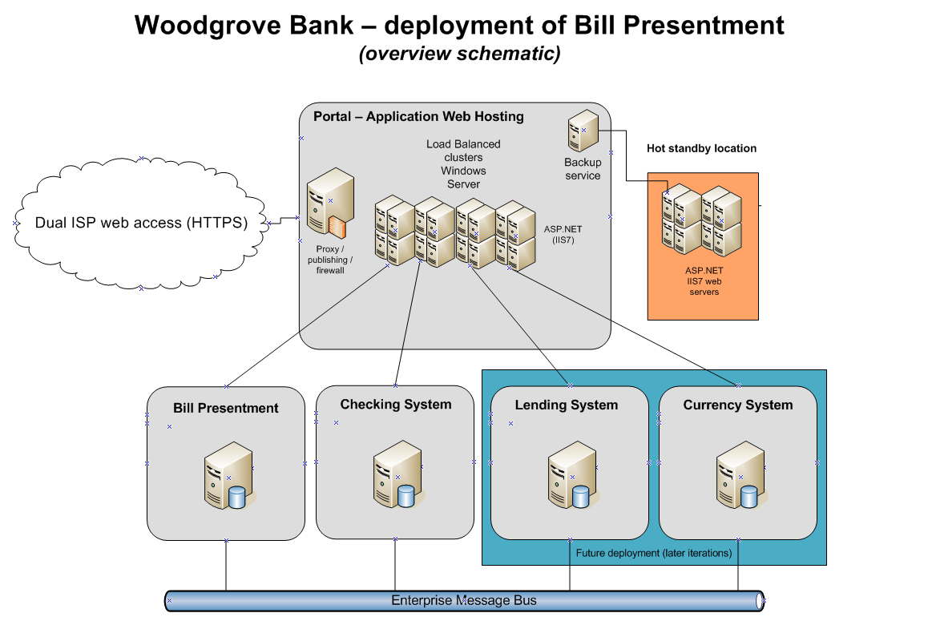

Placeholder for Woodgrove Bank deployment design